Q1.1
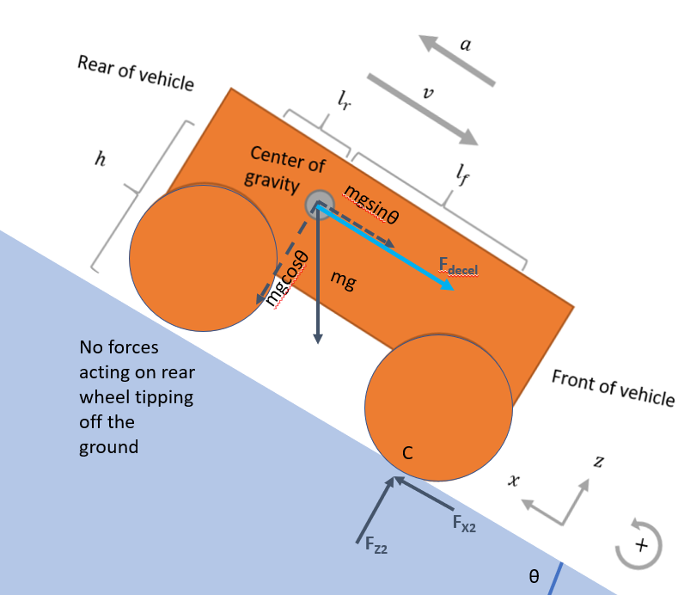 F_{z1} , F_{x1} ≈ zero just at tipping point about point C
Q1.2
To determine maximum deceleration, we consider moments about point C
F_{decel} = m × a
$$a<g(cosθ \frac{l_{f}}{h}-\sin{θ})$$

Q1.3
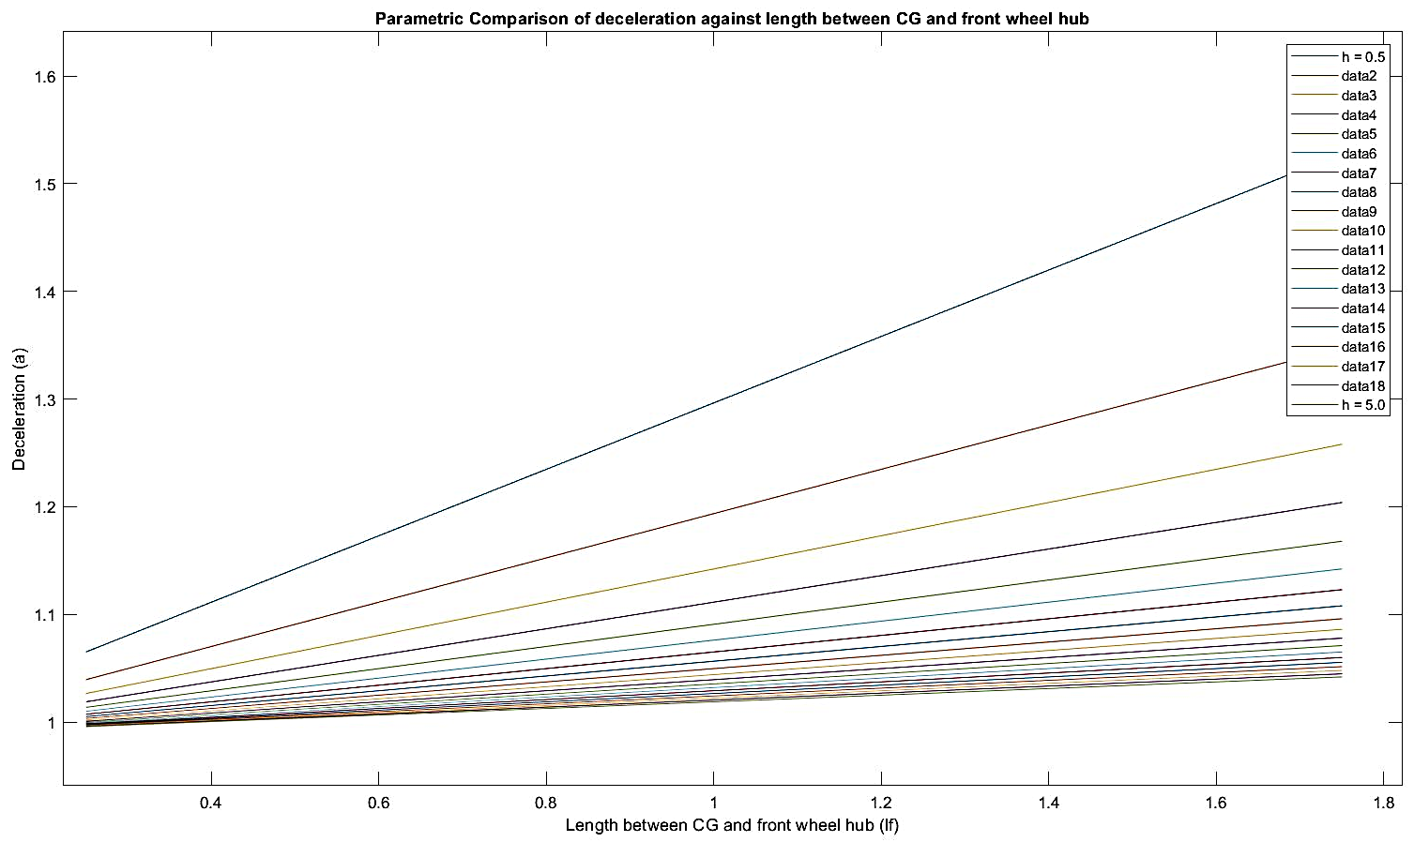

Q1.4
- The greatest deceleration was achieved with lf = 1.75m and h = 0.5m, this was the longest front wheel distance away from CG, and lowest CG height from ramp surface.
- This combination is expected as it requires a greater deceleration force to produce the same moment about point C to result in the vehicle tipping over with point C as the fulcrum.
- The selection of these parameter l_{f} depends on the application of the ground vehicle and the requirements of its volumetric footprint. If the default size of the vehicle already at the design limit, then one strategy to improve it’s stability during deceleration on slope is to lower h by keeping heavy equipment and components low in the chassis. The deceleration of the ground vehicle may not require the designer to use longest l_{f} and the lowest h, perhaps due to braking and motor limitations. If this were a very slow moving vehicle operating in a remote environment, there may not be a need for such high decelerations and hence the enabling the designer to choose a shorter l_{f} and permit a higher h.
Code for Q1:
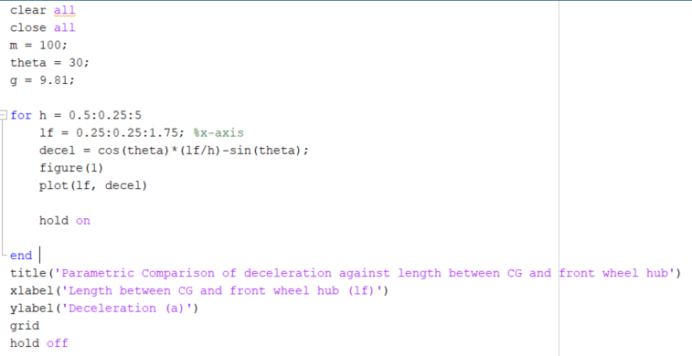

Q2.1
The 6-wheeled vehicle is better for minimizing compaction resistance. As a quick intuitive check by inspection of the compaction resistance formula, we expect that a lower F_{z} alone results in a lower compaction resistance. For a fixed wheel type and given weight, W, and even distribution across the wheels, F_{z} = W / number of wheels. Hence the 6-wheeled vehicle would have lower F_{z} and therefore lower compaction resistance.
Arbitarily, let W be 100 tons. W / 6 = 16.67 units of force; whereas W /4 = 25 units of force per wheel. The 4-wheeled vehicle has 1.5x more compaction resistance than its 6-wheeled variant.
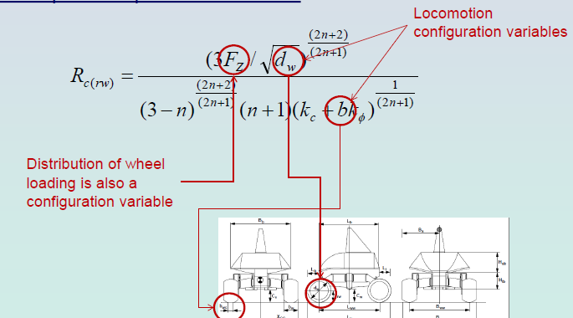
Q2.2
Soil thrust, H = cA + W tan ø, where W = σA
$H4:H6=\frac{c(1.2)A + W tan ø}{cA+ W tan ø}$
Q2.3
Drawbar pull, H - R_{compaction} = cA + W tan ø - $\frac{3F_{z}{\sqrt{d}}^{\frac{3}{2}}}{{2.5}^{\frac{3}{2}} \left(1.5\right){(k_{c}+bk_{ø})}^{\frac{1}{2}}}$
Q2.4
H = cA + W tan ø . In homogenous loose sand, the sample would contain no cohesive properties and soil thrust would increase with the vehicle weight proportionally. In compact clay, the frictional component of soil is equal to zero. The equation is reduced to cA which implies a higher value of thrust is obtained by an increase in contact surface area. Vehicles that traverse in highly frictional soils benefit from an increase in payload. In soil types that are very cohesive (high moisture content), vehicles experience higher thrust with increase in contact surface area. An increase in weight in this type of soil would be disadvantageous.
Ref: Laughery, S., Gerhart, G., Goetz, R (1990) Bekker’s Terramechanics Model for Off-road Vehicle Research. Extracted 2 Oct 2020 from https://apps.dtic.mil/dtic/tr/fulltext/u2/a457955.pdf
Q2.5
The other forms of resistance are R_{obstacles}, R_{bulldozing}, R_{turning}, R_{internal}

Q2.6
W_{gross} = gross weight of vehicle
n – number of wheels per axle
m – total number of axles
b – average unloaded tire width (in)
d – average unloaded tire diameter (in)
δ – average tire deflection (in)
A lower value of MMP indicates less sinkage, which means that there is better soil trafficability, movement speed and vehicle mobility. However, MMP alone does not fully quantify a platform’s mobility over specific terrain types. This can be supplemented by information provided by the Limiting Cone Index. The correlation of the MMP and CIL can be used to determine if the terrain is passable to a particular vehicle. Nonetheless, I would choose the one with MMP = 40 if MMP were the only criteria to consider.
Ref: Wong, Y. C. D., Lim H. H. S., Chan, W. Q. W (2016) An Assessment of Land Vehicles’ Trafficability. DSTA Horizons. Extracted 3 Oct 2020 from https://dsta.gov.sg/docs/default-source/dsta-about/an-assessment-of-land-vehicles-trafficability.pdf?sfvrsn=2
Q3
3.1
Skid | Articulated body
Ackerman | Explicit (independent) wheel articulation

3.2
Skid  Advantage:  Disadvantage: | Articulated body  Advantage:  Disadvantage:
Ackerman  Advantage:  Disadvantage: | Explicit (independent) wheel articulation  Advantage:  Disadvantage:

Q3.3
Semi-active suspension over
Passive suspension

